5.7 Exercises
5.7.1 Computational
- NEON data are submitted to AmeriFlux quarterly after one year of non-quality flagged or otherwise missing data are available. Use the workflow above to extend the data coverage of an already submitted NEON site by downloading existing data from the AmeriFlux website and recently published HDF5 files from the NEON data portal. Process the NEON data such that it is in AmeriFlux format and plot the entire timerseries.
Hint: NEON sites start with US-x
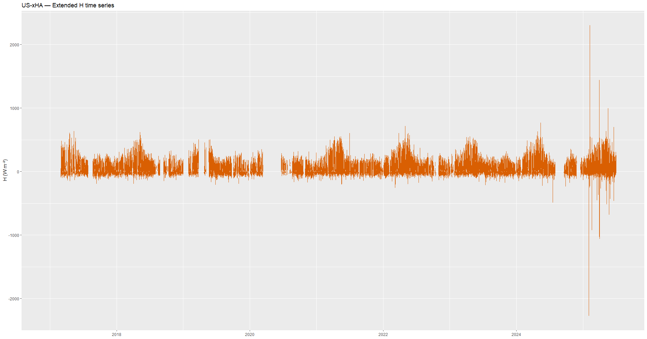
- Using metScanR package, find co-located NEON and AmeriFlux sites. Download data for an overlapping time period, and compare FC and H values by making a scatter plot and seeing how far off the data are from a 1:1 line.

